Sim now accepts data from “input.csv”

Every 13 values will be converted as follows:

OculusPositionX, OculusPositionY, OculusPositionZ, OculusRotationX, OculusRotationY, OculusRotationZ,

ObjectPositionX, ObjectPositionY, OculusPositionZ, OculusRotationX, OculusRotationY, OculusRotationZ,

RoomMaterial(A number that represents a position in an array of materials)

**Example**: using the input of 5,2.5,5,90,90,90,5,0,9,20,20,20,2

This is the scene before the data is loaded:

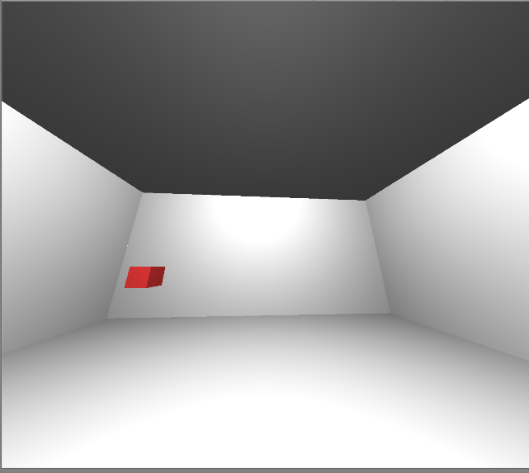

This is the scene after the data is loaded, without the oculus moving in between:

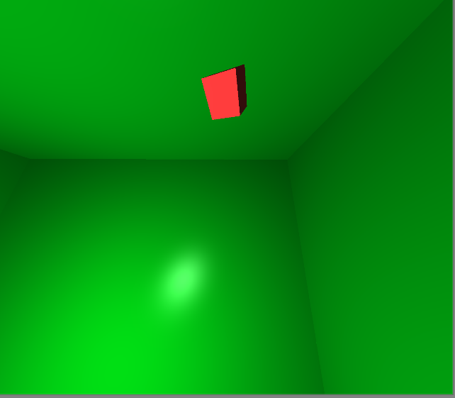

Room Color Note: The list of colors the room can be is not hardcoded. The list can be any size and contain anything that can be created in photoshop or taken with a camera instead of a solid color.

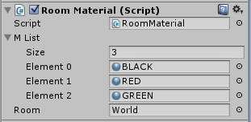

If requested the code can be modified to load images from a file, should the library of images be expected to change after the sim is exported to an executable. At the moment they must be loaded into the Unity Editor, made into materials (a simple task), and dragged into the above slots.

NOTE: During testing the oculus’s screens began flashing erratically. (While I was not wearing it.) Turning it off and on again solved this, but the idea that this could happen while a participant is wearing this is troubling. Turning the device off when not in use might help.